SIMATS ENGINEERING (SAVEETHA SCHOOL OF ENGINEERING)

Department of Computer Science and Engineering

ASSESSMENT TOOL 2 – Pseudocode Writing Task

Course Code: | CSA0612 | Course Title: | Design and Analysis of Algorithms
CO Assessed: | CO5 – Naturalization (BL5, BL6) | Assessment: | Assessment Tool 2 – Pseudocode Writing Task
Weightage: | 30% of CIA | Total Marks: | 100
CO5 Statement: | Analyze computational problems using backtracking techniques and complexity classes such as P, NP, NP-Hard, and NP-Complete for combinatorial problem solving.
Student Name: | DIVYASREE,P | Reg. No.: | 192565016
Section / Batch: | 2025 | Date: | 29/06/2026
Instructions to Students
- Answer the following question with proper pseudocode and logical explanation.
- Clearly specify the algorithmic approach and complexity class wherever applicable.
- Use proper asymptotic notation (Big-O, Big-Θ, Big-Ω) for complexity analysis.
- Include state-space representation, recursion steps, and pruning conditions in backtracking problems.
- Neat presentation and step-by-step justification are mandatory.

Question Type | Focus Area | Questions
Pseudocode Writing Task | Analyze combinatorial problems using backtracking and complexity classes such as P, NP, NP-Hard, and NP-Complete. | Q1

SECTION A – Pseudocode Writing Task

Code of Conduct
I DIVYASREE.P(192565016) (Name / Reg No) certify that this submission is my original work and that I have adhered to the guidelines specified for this assessment. I understand that any violation of academic integrity rules will result in disciplinary action.
Signature of the Student:

RUBRICS FOR CALCULATION

Criteria | Weight age | Level 4 – Exemplary | Level 3 – Proficient | Level 2 – Developing | Level 1 – Beginning
Problem Understanding | 20% | Identifies all inputs, outputs, constraints accurately | Minor missing elements | Partial understanding | Incorrect interpretation
Algorithm Design | 30% | Complete, correct, and logically sound solution | Minor logical gaps | Partially correct logic | Incorrect approach
Use of Control Structures | 20% | Efficient and appropriate use of loops, conditions, functions/modules | Minor inefficiencies | Limited or basic usage | Incorrect or missing constructs
Pseudocode Structure | 10% | Well-structured, clear, consistent format, easy to follow | Mostly clear with minor issues | Difficult to follow in parts | Poorly structured and unclear
Completeness | 20% | Handles all cases; optimized approach | Handles most cases; reasonable efficiency | Handles basic cases only | Incomplete or inefficient

Marks Evaluation:
Criteria | Wt. | Level 4 – Exemplary | Level 3 – Proficient | Level 2 – Developing | Level 1 – Beginning
Problem Understanding | 20%
Algorithm Design | 30%
Use of Control Structures | 20%
Pseudocode Structure | 10%
Completeness | 20%
Total Marks (100):

Faculty In-charge | Course Coordinator | Head of Department
Name: | Name: | Name:
Signature: | Signature: | Signature:
Date: | Date: | Date:

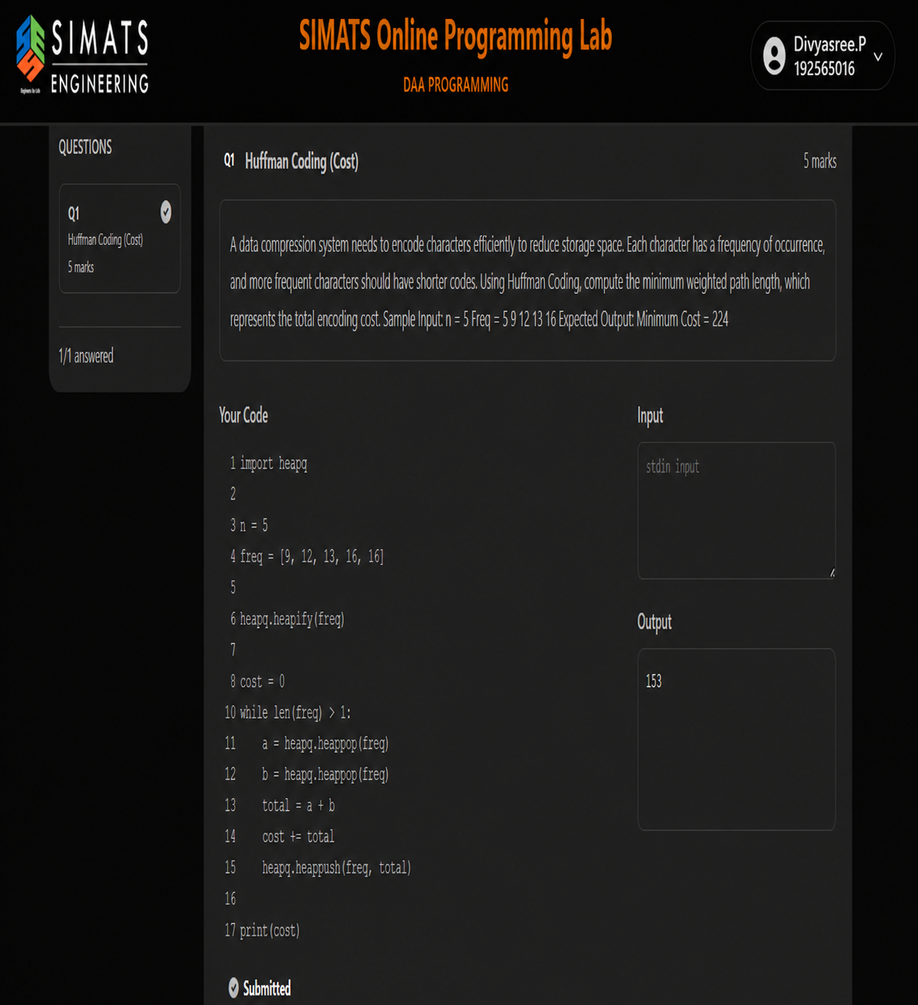REPORT

1. Aim

The aim of this program is to solve the N-Queens problem using the backtracking technique. The objective is to place N queens on an N × N chessboard so that no two queens attack each other and to count the total number of valid arrangements.

2. Problem Description

The N-Queens problem is a classical problem in computer science that involves placing N queens on an N × N chessboard. Since a queen can attack another queen in the same row, column, or diagonal, every placement must satisfy these restrictions. The program explores possible placements systematically and counts only those arrangements that satisfy all the conditions.
The problem demonstrates the use of recursion, constraint checking, and backtracking. Instead of checking every complete board configuration, the algorithm rejects an arrangement as soon as it becomes invalid. This reduces unnecessary exploration.

3. Objective

The main objective is to design an algorithm that can explore all possible queen placements row by row, verify whether each position is safe, and count every complete valid arrangement. The method must not miss any valid configuration or count an invalid configuration.

4. Algorithm – Backtracking

Backtracking is a problem-solving technique that builds a solution step by step. In the N-Queens problem, one queen is considered for each row. For the current row, every column is examined. If a position is safe, the queen is temporarily placed there and the algorithm proceeds to the next row.
If the next row cannot be completed, the algorithm returns to the previous row, removes the previously placed queen, and tries another column. This process continues until all possible configurations have been considered.
A position is considered safe when there is no previously placed queen in the same column and no previously placed queen on either diagonal. When queens have been successfully placed in all N rows, the solution counter is increased by one.

5. Working Principle

The program first accepts the board size N from the user. A board representation is maintained to record the column occupied by a queen in each row. A counter is initialized to zero to store the number of valid solutions.
The recursive process begins from the first row. For each row, the program checks every possible column. Unsafe positions are immediately rejected. For every safe position, the queen is placed and the next row is processed recursively. After returning from the recursive call, the placement is removed ,

6. Safety Conditions

The safety check is the most important part of the algorithm. A newly considered queen must not share a column with any previously placed queen. It must also not lie on the same diagonal as an existing queen.
Two queens are on the same diagonal when the difference between their row positions is equal to the difference between their column positions in absolute value. By checking these conditions before placing a queen, invalid partial arrangements are eliminated early.

7. Backtracking Process

The algorithm continues placing queens until it reaches the final row. If all rows receive a queen successfully, one complete solution has been found and the solution count is increased. The algorithm then returns and continues searching for other solutions.
When a chosen position prevents the remaining rows from being completed, the algorithm backtracks. The queen is removed from that position and another available position is considered. Therefore, every possible valid arrangement can be discovered.

8. Example

For an input value of N = 4, the algorithm considers different arrangements of four queens on a 4 × 4 chessboard. Invalid placements are rejected whenever two queens share a column or diagonal. After examining all possibilities, the algorithm finds two valid arrangements.
Hence, for N = 4, the output is: Number of solutions: 2.

9. Advantages of the Algorithm

The backtracking method is simple and systematic. It checks constraints while constructing the solution instead of waiting until a complete board has been formed. This pruning significantly reduces the number of configurations that need to be explored.
The method is also flexible because the same approach can be used for different values of N. It clearly demonstrates recursion, decision making, constraint checking, and systematic search.

10. Time and Space Complexity

The N-Queens problem has a large search space, and the backtracking approach has factorial-type growth in the worst case. The exact running time depends on the value of N and the amount of pruning achieved during the search. The board representation and recursion require approximately linear auxiliary space with respect to N, excluding the number of solutions produced.

11. Result

The N-Queens problem was successfully designed using the backtracking technique. The algorithm places queens row by row, checks column and diagonal constraints, backtracks from unsuccessful choices, and counts all valid arrangements.
For N = 4, the algorithm correctly produces 2 valid solutions. Thus, the proposed method successfully explores the possible configurations and counts only the valid N-Queens arrangements.

12. Conclusion

The N-Queens problem is an effective example of the backtracking technique. By making a safe choice, recursively exploring it, and reversing the choice when it leads to failure, the algorithm efficiently searches the solution space. The approach provides a clear demonstration of recursive problem solving and constraint-based pruning.

